Planning

🌟 Definition
# Source: AI Source: Provided by: [Data Path: Persons Table -> ID Column: 1, Name_En Column: Motasem Essam] -> From: [ChatGPT] on [6/7/2026]
Planning is the first phase of the Software Development Life Cycle (SDLC) where the project idea is analyzed, goals are defined, resources are estimated, and a roadmap is created for developing the software.
The main question in this phase is:
"What should we build, why do we need it, and how will we build it?"

🎯 Purpose of Planning Phase
# Source: AI Source: Provided by: [Data Path: Persons Table -> ID Column: 1, Name_En Column: Motasem Essam] -> From: [ChatGPT] on [6/7/2026]
The Planning phase aims to:
- Understand the business problem
- Define project objectives
- Identify requirements at a high level
- Estimate cost and time
- Identify risks
- Decide whether the project is feasible

🔄 Planning Phase Process
# Source: AI Source: Provided by: [Data Path: Persons Table -> ID Column: 1, Name_En Column: Motasem Essam] -> From: [ChatGPT] on [6/7/2026]
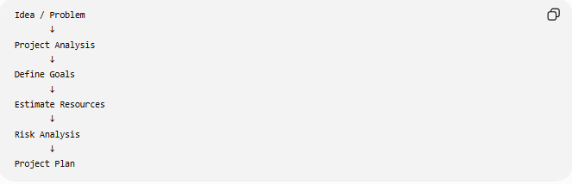
Idea / Problem
↓
Project Analysis
↓
Define Goals
↓
Estimate Resources
↓
Risk Analysis
↓
Project Plan

🧩 Main Activities in Planning Phase

1️⃣ Identify the Problem
# Source: AI Source: Provided by: [Data Path: Persons Table -> ID Column: 1, Name_En Column: Motasem Essam] -> From: [ChatGPT] on [6/7/2026]
Definition
Understand the reason for creating the software.
Questions:
- What problem are we solving?
- Who needs this software?
- Why is the current system not enough?

Example
Problem:
A company manages customers using Excel files.
Data is duplicated and difficult to search.
Solution:
Build a Customer Management System.

2️⃣ Define Project Goals
# Source: AI Source: Provided by: [Data Path: Persons Table -> ID Column: 1, Name_En Column: Motasem Essam] -> From: [ChatGPT] on [6/7/2026]
Definition
Set clear objectives that the software should achieve.
Examples:
✅ Reduce manual work
✅ Improve data accuracy
✅ Automate processes
✅ Increase customer service speed

Example:
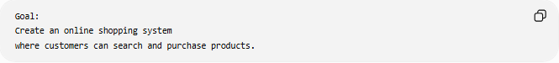
Goal:
Create an online shopping system
where customers can search and purchase products.

3️⃣ Identify Stakeholders
# Source: AI Source: Provided by: [Data Path: Persons Table -> ID Column: 1, Name_En Column: Motasem Essam] -> From: [ChatGPT] on [6/7/2026]
Definition
Stakeholders are people or organizations affected by the software.
Examples:
- Customers
- Managers
- Developers
- System administrators
- Business owners

Example:
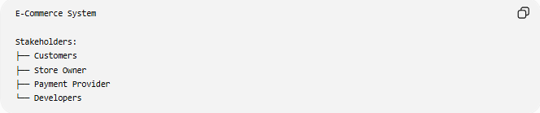
E-Commerce System

Stakeholders:
├── Customers
├── Store Owner
├── Payment Provider
└── Developers

4️⃣ Feasibility Study
# Source: AI Source: Provided by: [Data Path: Persons Table -> ID Column: 1, Name_En Column: Motasem Essam] -> From: [ChatGPT] on [6/7/2026]
Definition
Determines whether the project is possible and practical.

Types of Feasibility
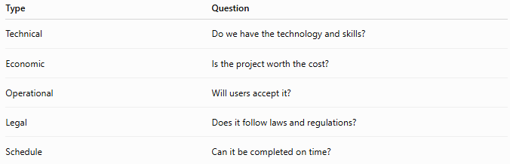
Type | Question
Technical | Do we have the technology and skills?
Economic | Is the project worth the cost?
Operational | Will users accept it?
Legal | Does it follow laws and regulations?
Schedule | Can it be completed on time?

Example
Question:
Can we build an AI system with the available budget?

5️⃣ Estimate Resources
# Source: AI Source: Provided by: [Data Path: Persons Table -> ID Column: 1, Name_En Column: Motasem Essam] -> From: [ChatGPT] on [6/7/2026]
Resources include:
👨‍💻 Human Resources
Examples:
- Developers
- Designers
- Testers
- Project Managers

💻 Technical Resources
Examples:
- Servers
- Databases
- Development tools

💰 Financial Resources
Examples:
- Development cost
- Hosting cost
- Maintenance cost

6️⃣ Risk Analysis
# Source: AI Source: Provided by: [Data Path: Persons Table -> ID Column: 1, Name_En Column: Motasem Essam] -> From: [ChatGPT] on [6/7/2026]
Definition
Identify possible problems before development starts.

Examples:
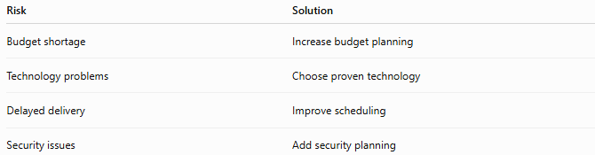
Risk | Solution
Budget shortage | Increase budget planning
Technology problems | Choose proven technology
Delayed delivery | Improve scheduling
Security issues | Add security planning

7️⃣ Define Project Scope
# Source: AI Source: Provided by: [Data Path: Persons Table -> ID Column: 1, Name_En Column: Motasem Essam] -> From: [ChatGPT] on [6/7/2026]
Definition
Defines what the software will include and exclude.

Example:
Included:
✅ User registration
✅ Product search
✅ Online payment

Not Included:
❌ Mobile application
❌ AI recommendations

8️⃣ Create Project Plan
# Source: AI Source: Provided by: [Data Path: Persons Table -> ID Column: 1, Name_En Column: Motasem Essam] -> From: [ChatGPT] on [6/7/2026]
The project plan includes:
- Timeline
- Budget
- Team members
- Milestones
- Tools
- Development approach

Example:
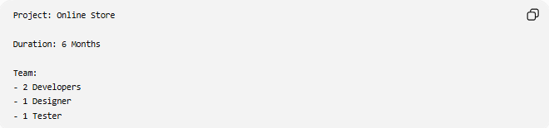
Project: Online Store

Duration: 6 Months

Team:
- 2 Developers
- 1 Designer
- 1 Tester

📄 Planning Phase Documents
# Source: AI Source: Provided by: [Data Path: Persons Table -> ID Column: 1, Name_En Column: Motasem Essam] -> From: [ChatGPT] on [6/7/2026]
Common documents created:
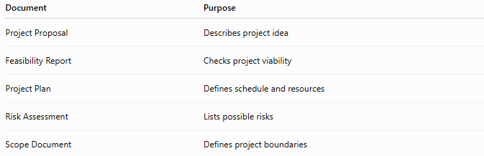
Document | Purpose
Project Proposal | Describes project idea
Feasibility Report | Checks project viability
Project Plan | Defines schedule and resources
Risk Assessment | Lists possible risks
Scope Document | Defines project boundaries

🛠️ Tools Used in Planning
# Source: AI Source: Provided by: [Data Path: Persons Table -> ID Column: 1, Name_En Column: Motasem Essam] -> From: [ChatGPT] on [6/7/2026]
Examples:
- Project management tools
- Requirement tracking tools
- Documentation tools
Common tools:
- Jira
- Microsoft Project
- Trello

📊 Planning Phase Output
# Source: AI Source: Provided by: [Data Path: Persons Table -> ID Column: 1, Name_En Column: Motasem Essam] -> From: [ChatGPT] on [6/7/2026]
At the end of planning, we should have:
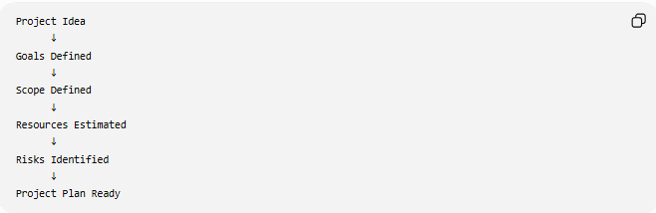
Project Idea
↓
Goals Defined
↓
Scope Defined
↓
Resources Estimated
↓
Risks Identified
↓
Project Plan Ready

🧠 Simple Analogy
# Source: AI Source: Provided by: [Data Path: Persons Table -> ID Column: 1, Name_En Column: Motasem Essam] -> From: [ChatGPT] on [6/7/2026]
Building a house:
Planning Phase
Before construction:
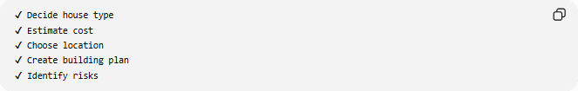
✔ Decide house type
✔ Estimate cost
✔ Choose location
✔ Create building plan
✔ Identify risks
Software planning works the same way:
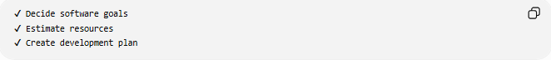
✔ Decide software goals
✔ Estimate resources
✔ Create development plan

🧭 Summary
# Source: AI Source: Provided by: [Data Path: Persons Table -> ID Column: 1, Name_En Column: Motasem Essam] -> From: [ChatGPT] on [6/7/2026]
The Planning Phase is the first stage of SDLC where the project idea is evaluated and a roadmap is created. Teams define goals, identify stakeholders, study feasibility, estimate resources, analyze risks, define scope, and prepare a project plan before actual software development begins. A strong planning phase reduces project failures and provides a clear direction for the entire software development process.

